**Week 12 -- Get ready for soft opening**

In week 12, we are preparing for our soft open presentation. Soft openness means letting faculties play our game and then make comments.

**Developer Feature**

Our game has 12 story lines, and the whole experience will be more than 2 hours. In order to make faculties more able to experience the uniqueness of our game, we plan to make a developer program to facilitate faculties to jump to any story line. At the same time, we are also preparing how to smoothly demonstrate the process of the game, to facilitate the faculties to show the characteristics of our game.

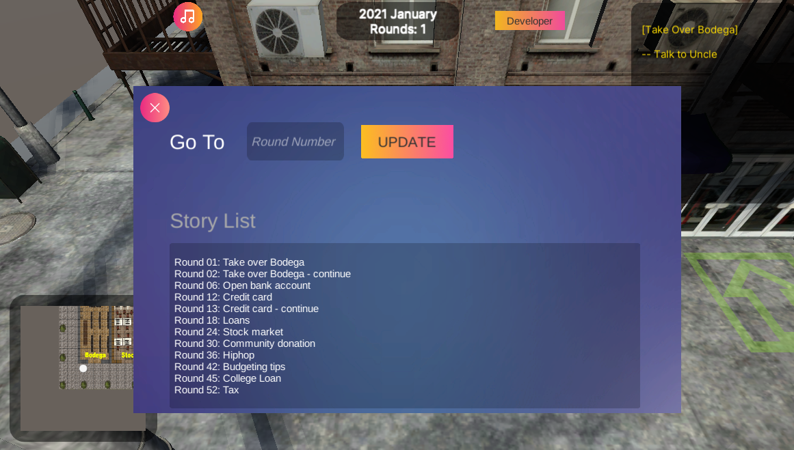

**UI Update**

To show faculties the integrity of the game, the game updated all the UI this week, including the new 2D avatars, maps, and icons in the game. At the same time, we also changed some small mechanisms. For example, we changed the tutorial at the beginning of the game to be shorter and easier, and then changed each story line into a part of the tutorial, which means that the player can unlock more functions of the game while playing. Of course, it also makes it more difficult for us to show our staff when we are soft open.

Old-----------------------New